Adversary Emulation Lab Report

Objective:

Simulate an APT29-style adversary attack using Caldera and Evilginx2, analyze persistence and phishing techniques, and evaluate Blue Team visibility through Wazuh detection logs.

Tools Used
- MITRE Caldera
- Evilginx2
- Wazuh SIEM
- Kali Linux
- MITRE ATT&CK Framework

Lab Environment
- Attacker Machine: Kali Linux
- Command and Control Framework: Caldera
- Detection Platform: Wazuh
- Target Environment: Windows endpoint monitored by Wazuh agent

Attack Scenario
The lab simulated an APT29-inspired attack chain involving phishing delivery, credential harvesting, command-and-control communication, execution of adversary techniques, and Blue Team monitoring. MITRE Caldera was used to orchestrate operations and emulate attacker behavior mapped to MITRE ATT&CK techniques.

MITRE ATT&CK Mapping

Phase | TTP | Tool Used | Notes
Phishing | T1566.001 | Evilginx2 | Credential harvesting through phishing simulation
Initial Access | T1078 | Caldera | Valid account style access simulation
Command and Control | T1071 | Caldera | Agent communication with C2 server
Persistence | T1053 | Caldera | Scheduled task / persistence simulation
Execution | T1059 | Caldera | Command execution through agent
Detection & Monitoring | T1119 | Wazuh | Log collection and event monitoring

Procedure and Analysis

Caldera Setup
Caldera framework was initialized successfully on the Kali Linux attacker system.

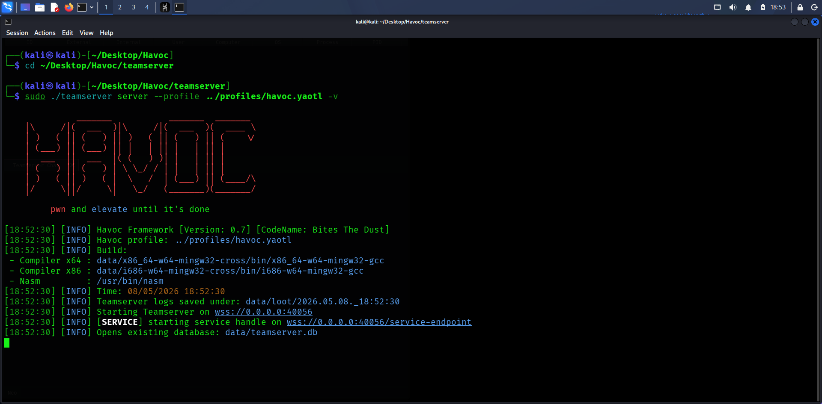

Agent Deployment
The Caldera agent deployment process was configured to establish communication with the C2 server.

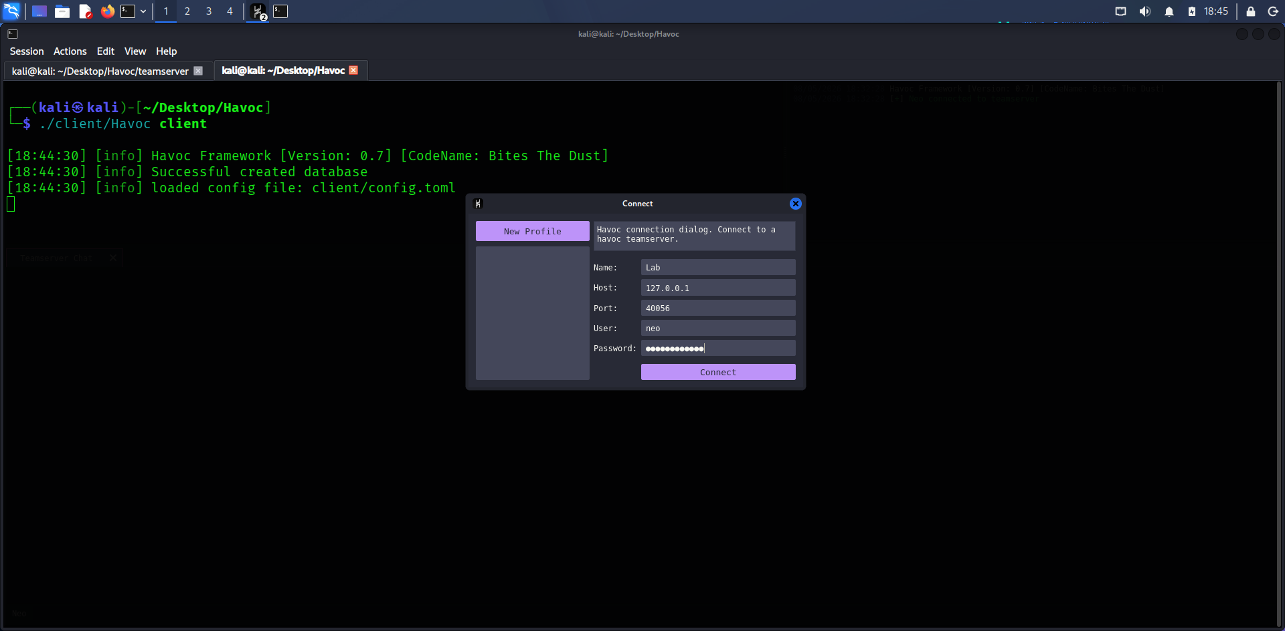

Ability Configuration
Custom abilities and execution parameters were reviewed and prepared inside Caldera.

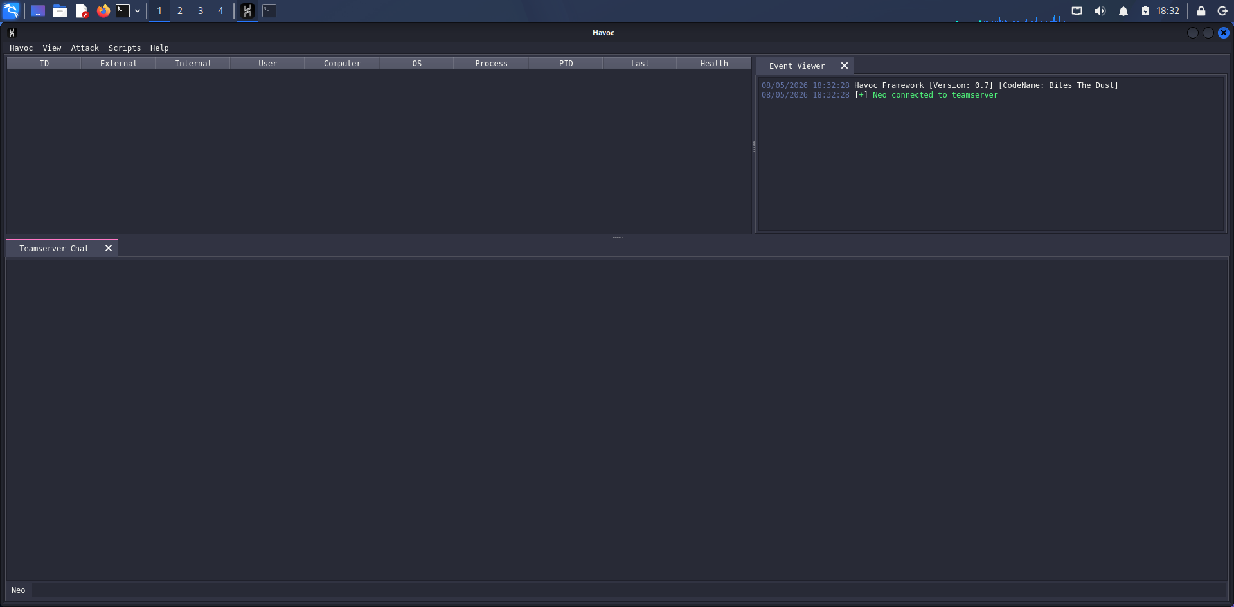

Operation Creation
A new adversary operation was configured using MITRE ATT&CK mapped techniques.

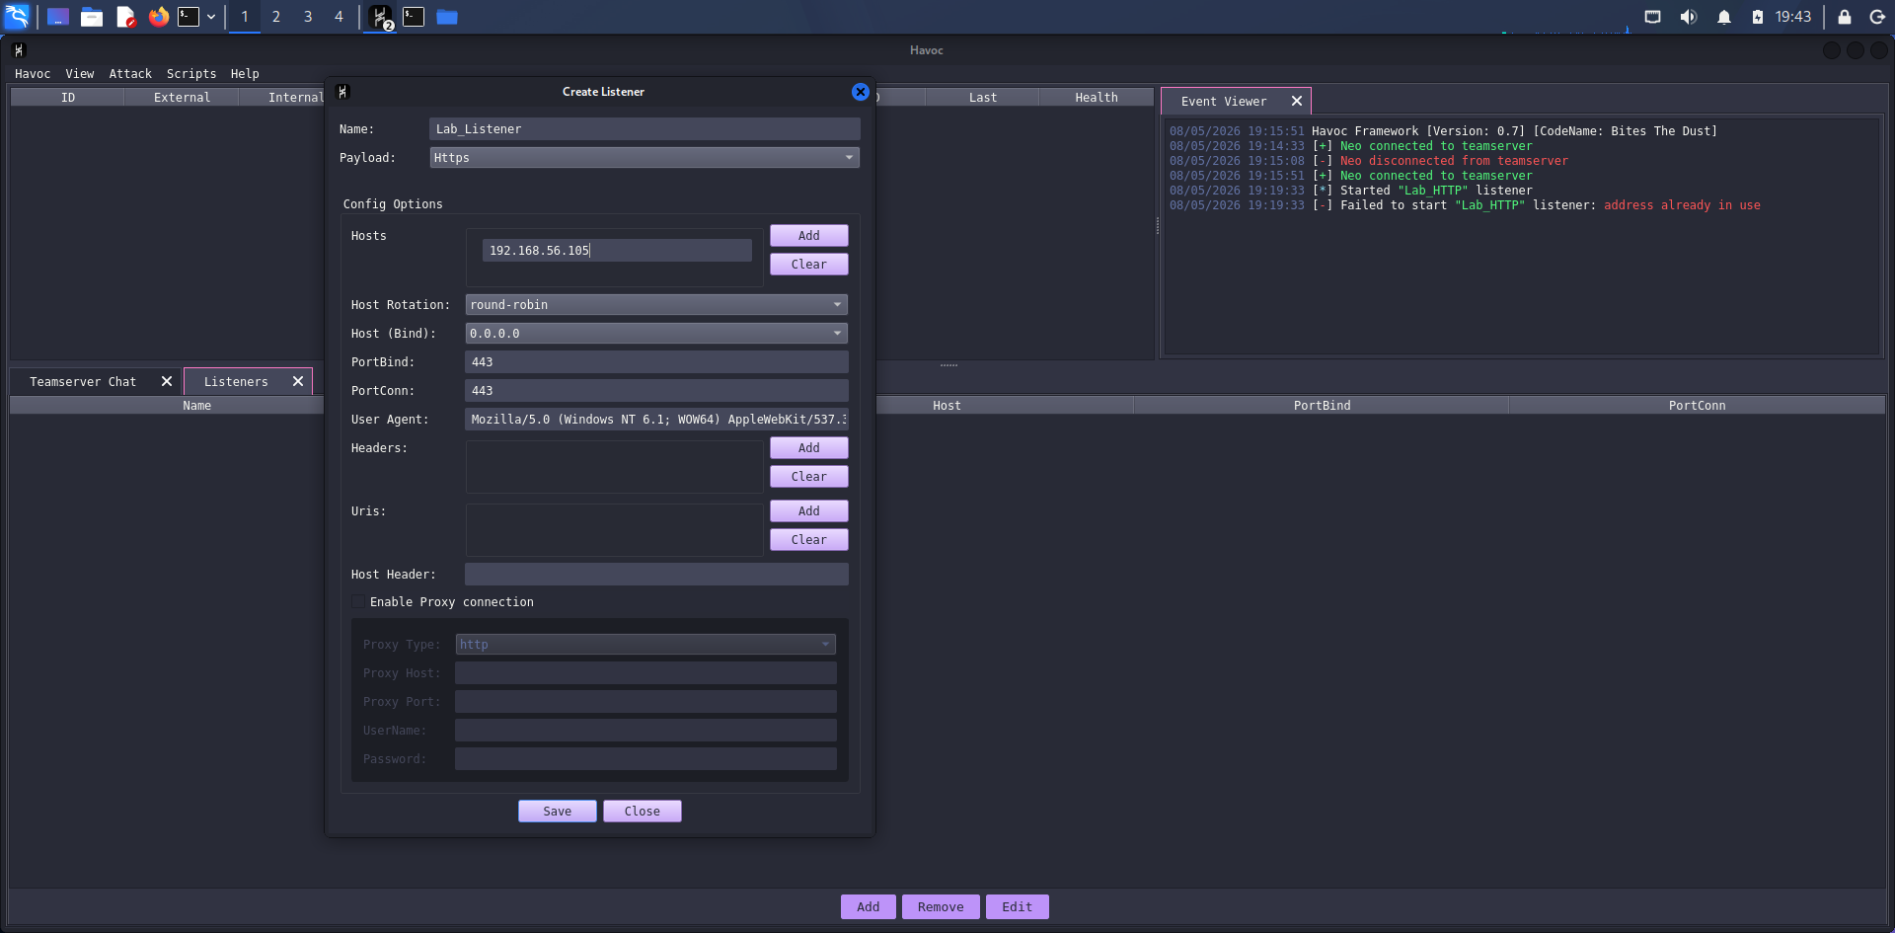

Adversary Profile Selection
Adversary profile and execution settings were selected before launching the operation.

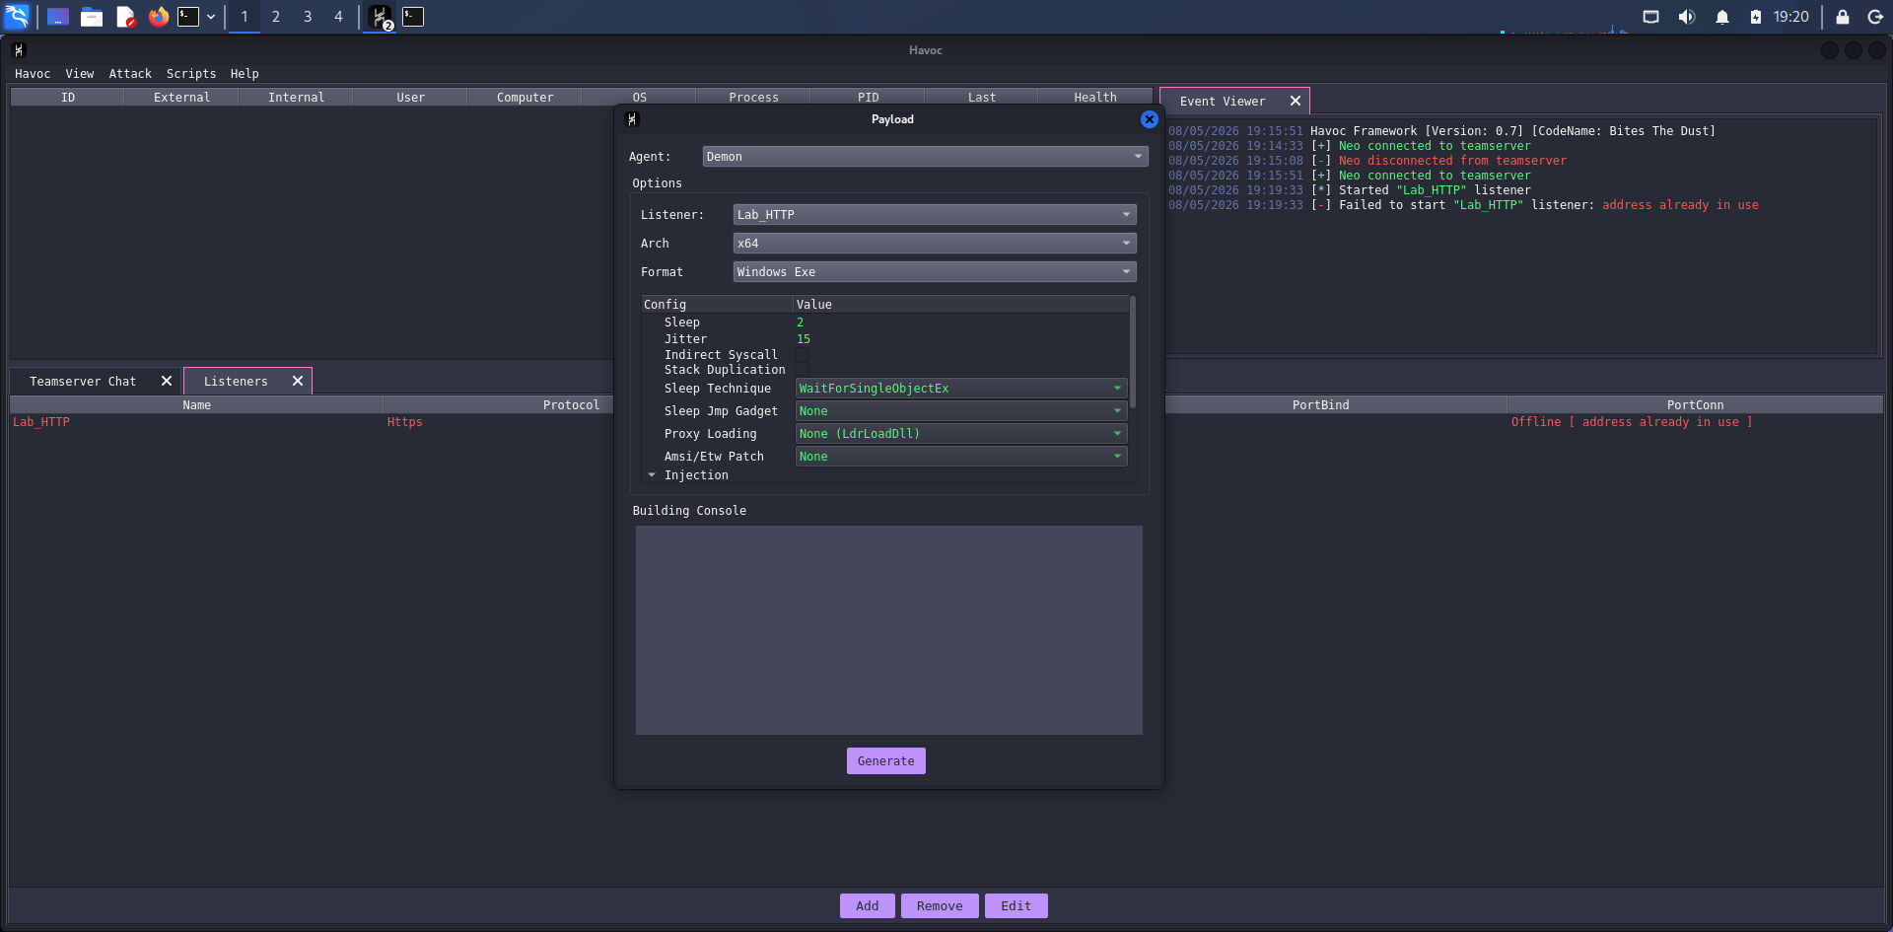

Operation Monitoring
The running operation was monitored to validate successful execution and callback activity.

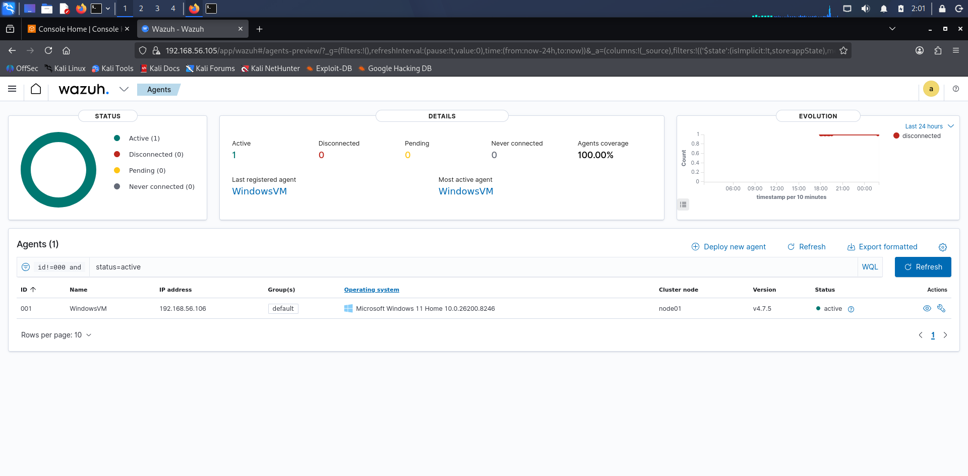

Caldera Execution Terminal
The terminal confirmed successful execution and operational status of the Caldera framework.

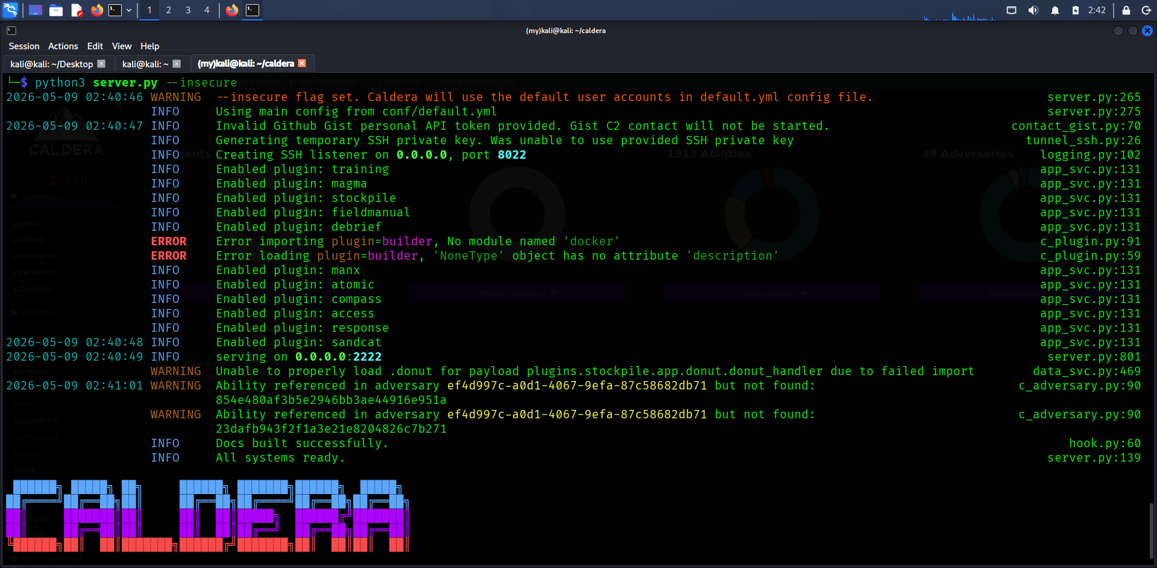

Dashboard Overview
The Caldera dashboard displayed operation statistics and execution summaries.

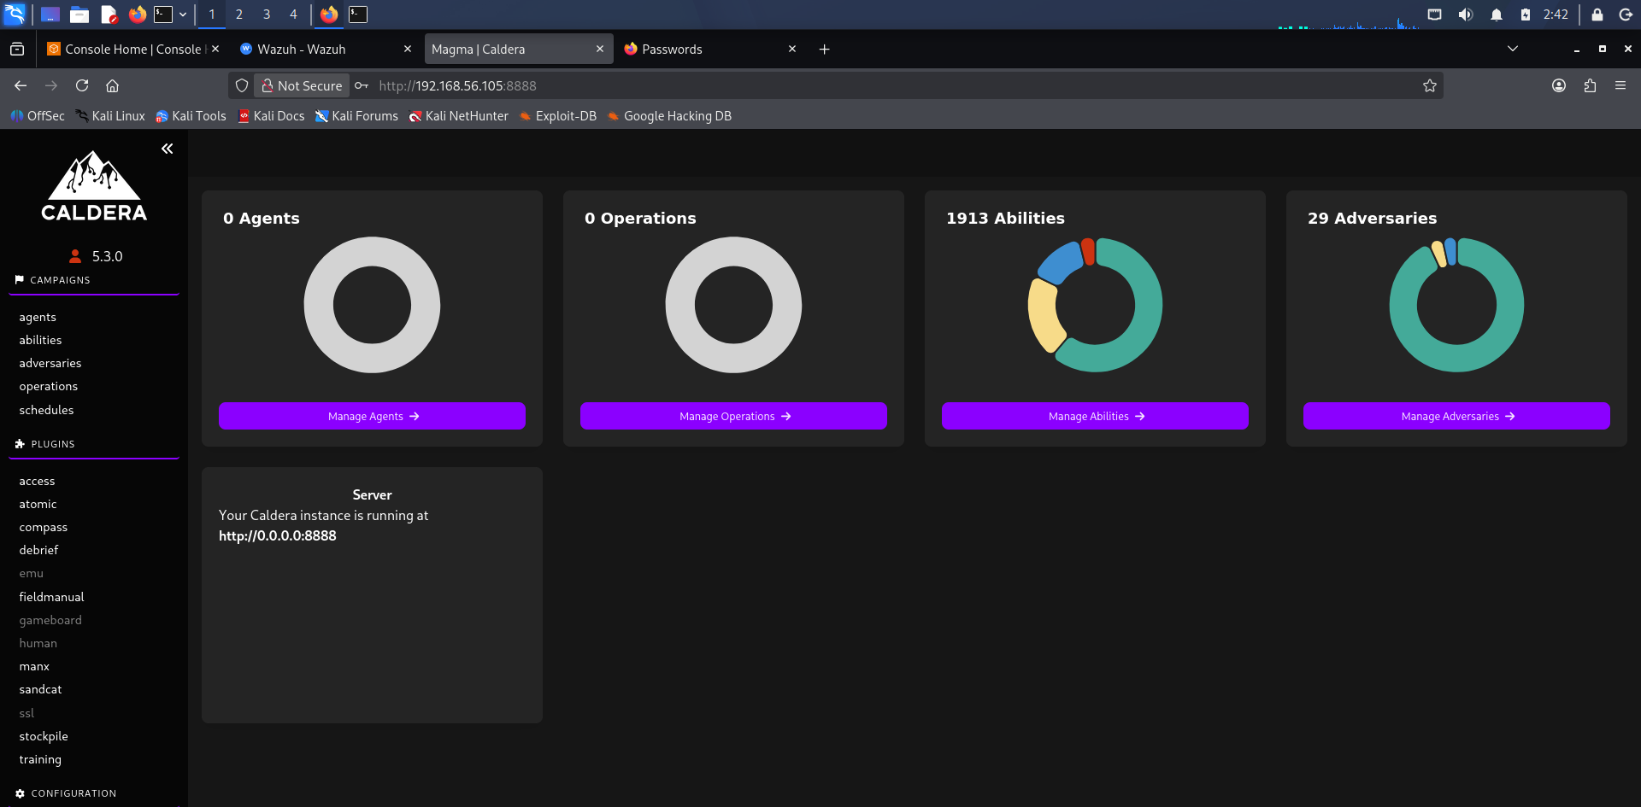

Active Agents
Connected agents were successfully listed and verified within Caldera.

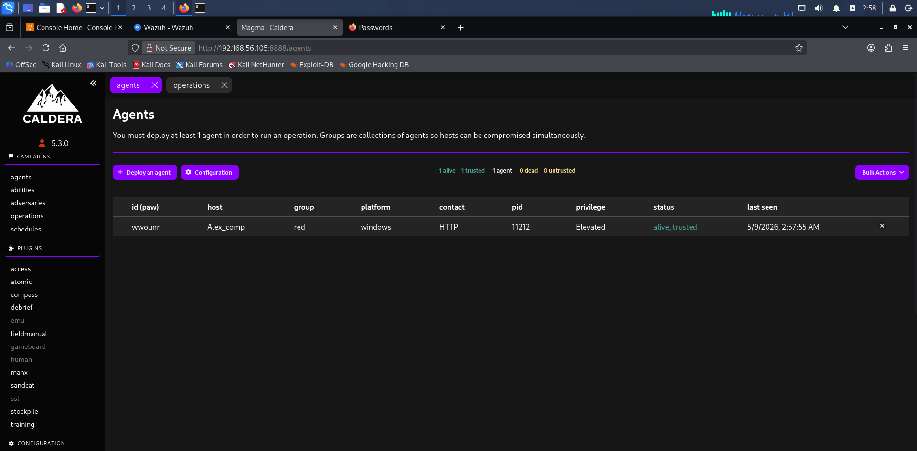

Operation Scheduling
The attack operation timing and execution configuration were customized.

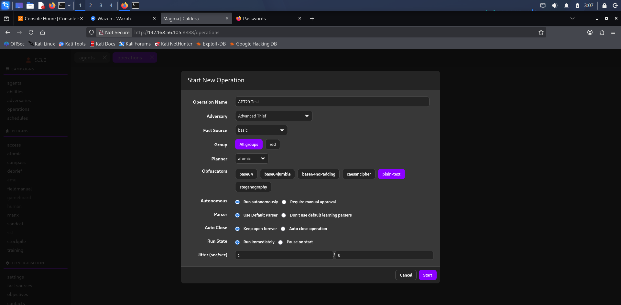

Operation Execution
The adversary emulation operation was launched successfully.

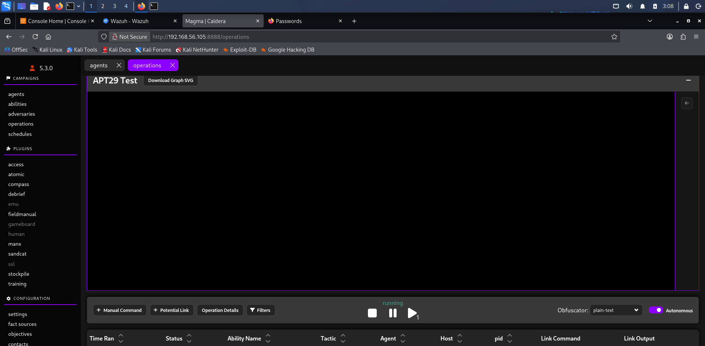

Operation Results
Execution results demonstrated successful adversary technique simulation.

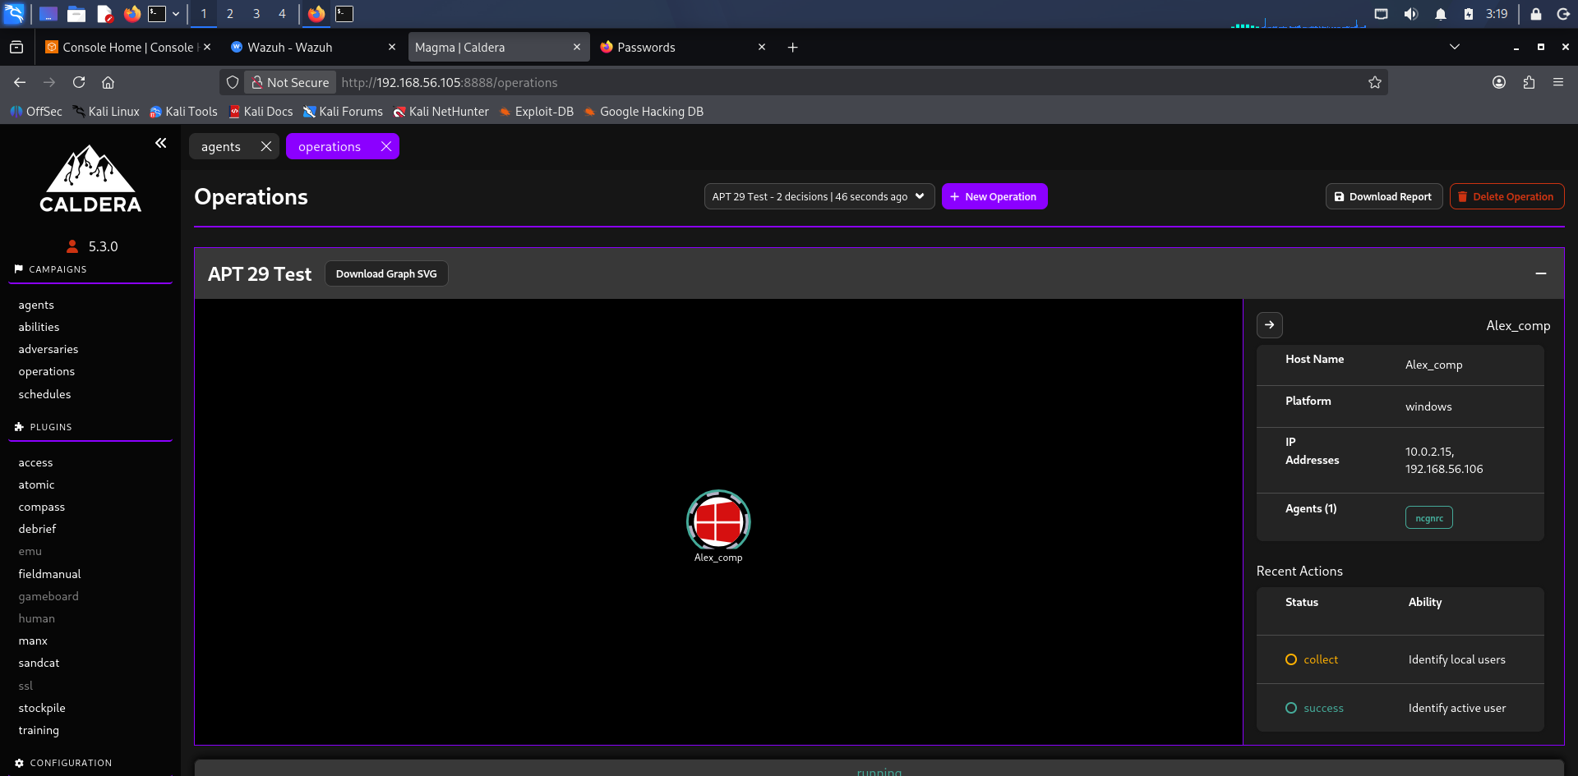

Detailed Attack Logs
Caldera generated detailed logs for each executed ATT&CK technique.

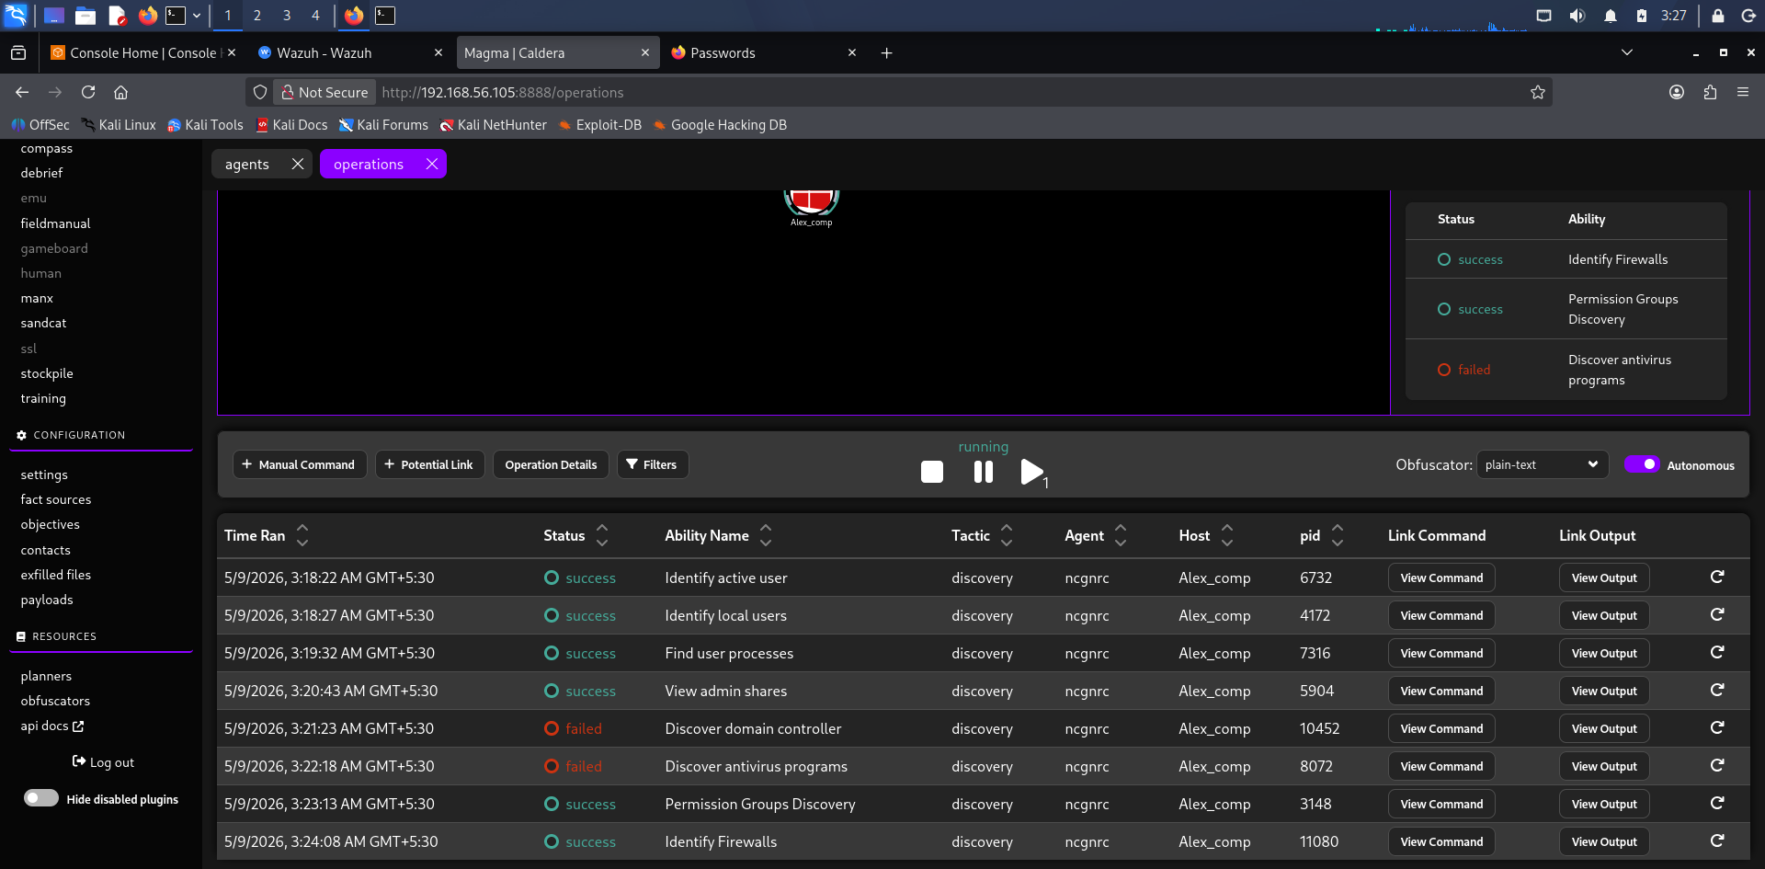

Wazuh Monitoring Dashboard
Wazuh dashboards monitored endpoint security events and system activity.

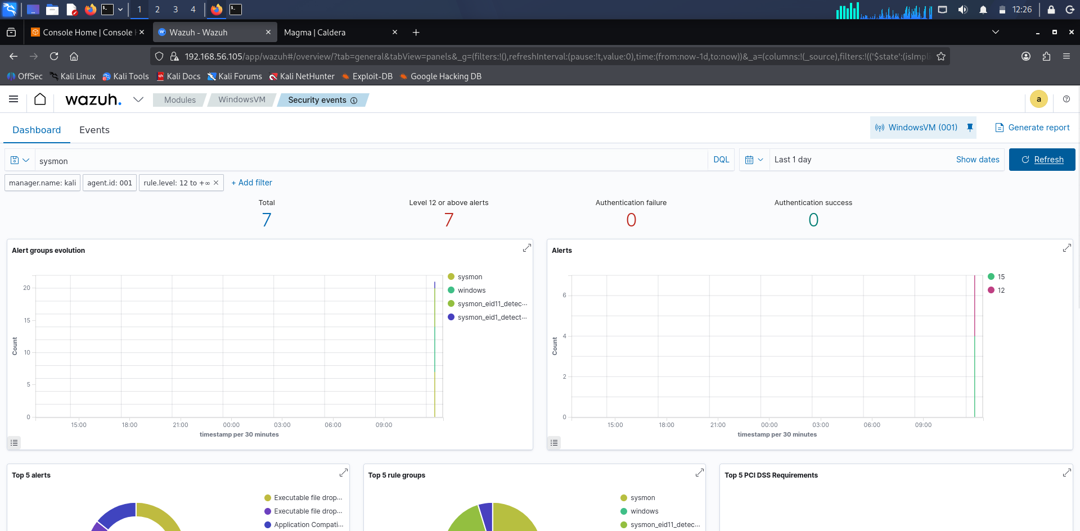

Wazuh Event Analysis
Security events generated during adversary activity were analyzed in Wazuh.

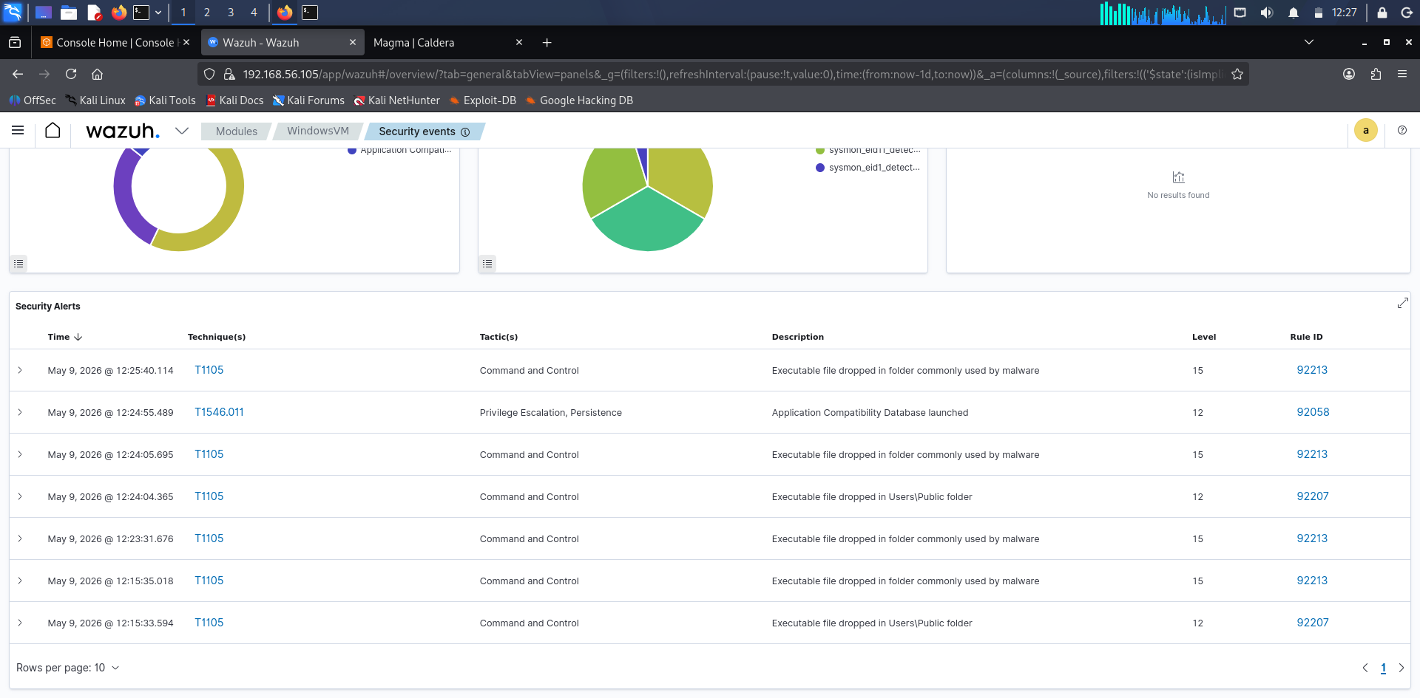

Detection Correlation
Detection events and alerts were correlated with simulated adversary actions.

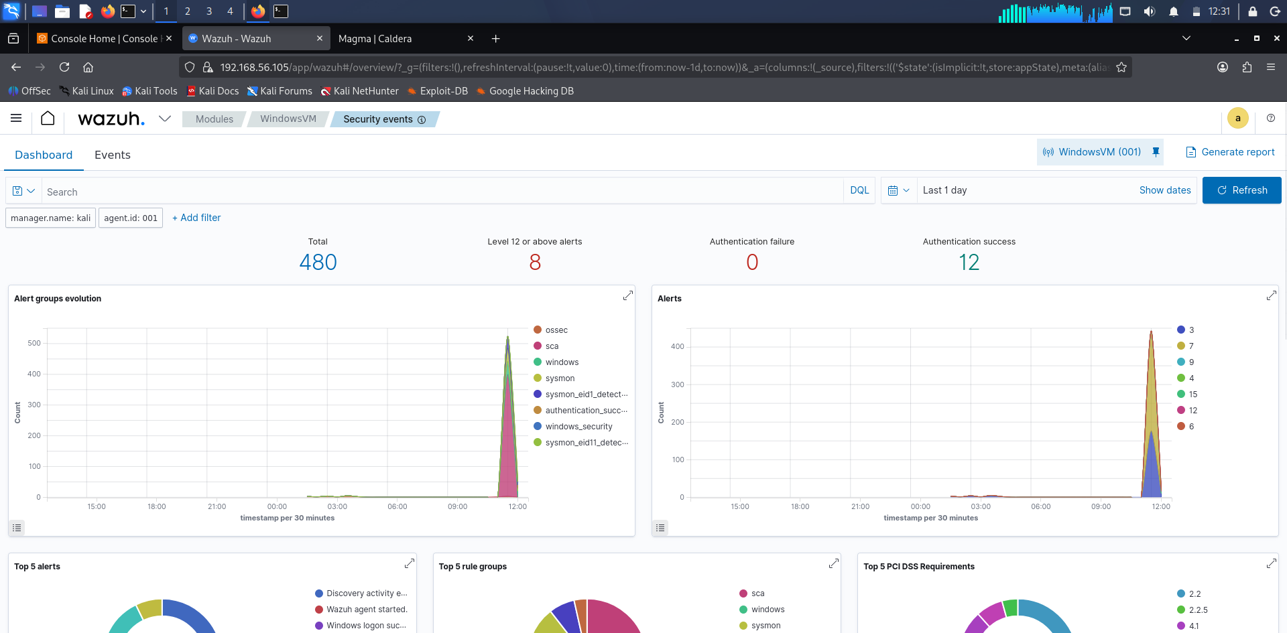

Security Event Visualization
Graphical dashboards displayed categorized attack-related telemetry.

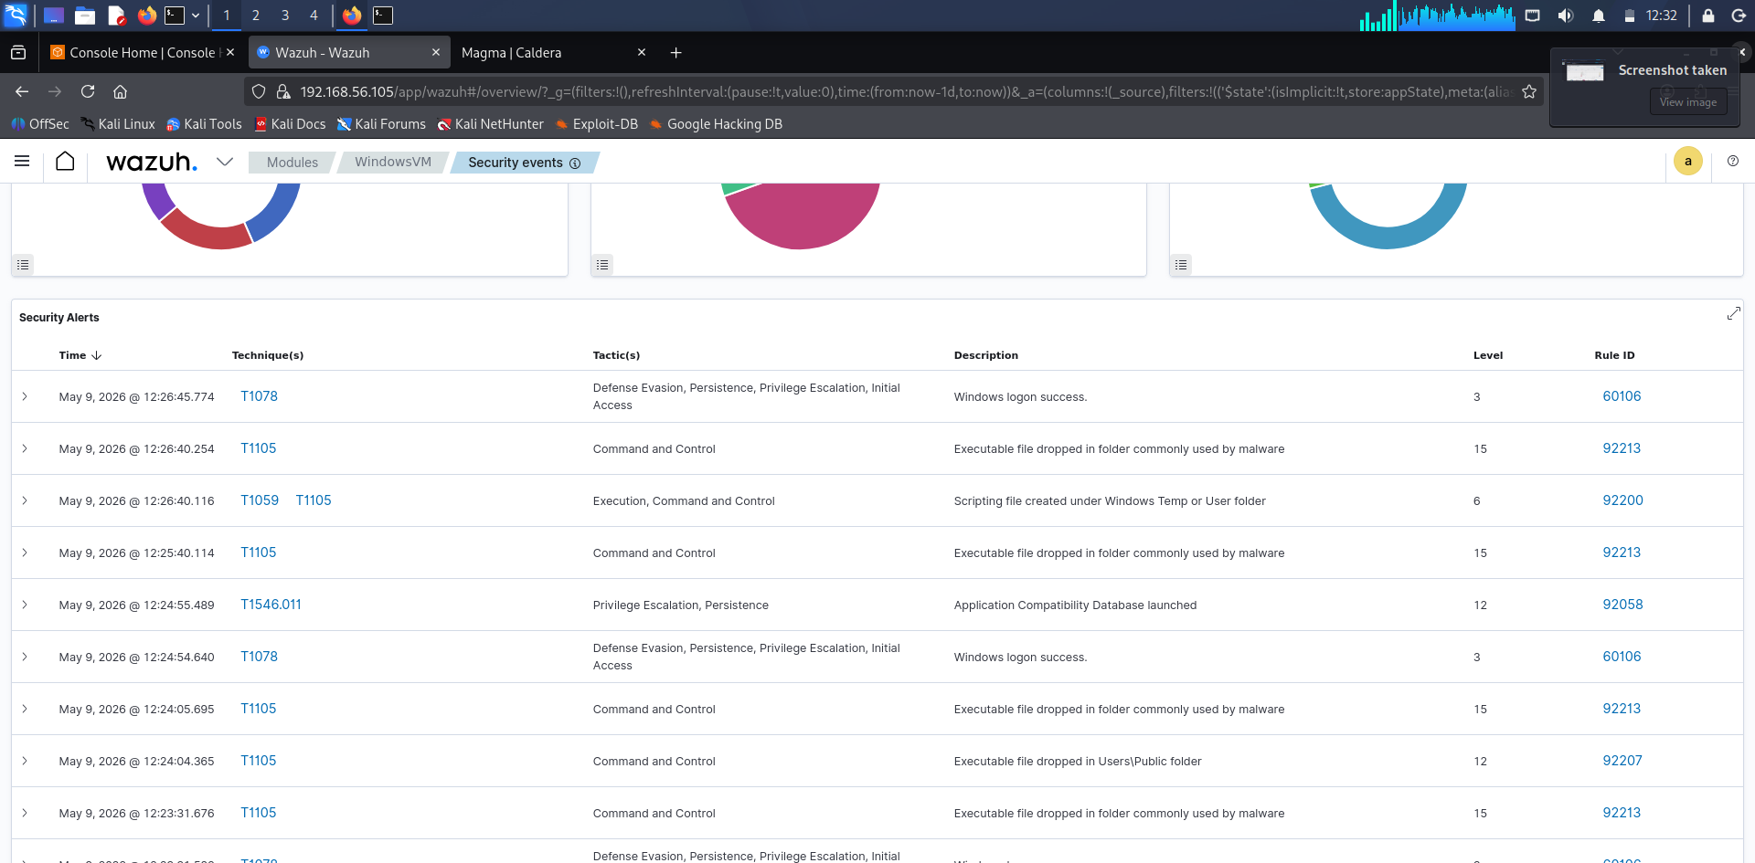

Blue Team Investigation
Blue Team analysis validated successful detection visibility for multiple attack stages.

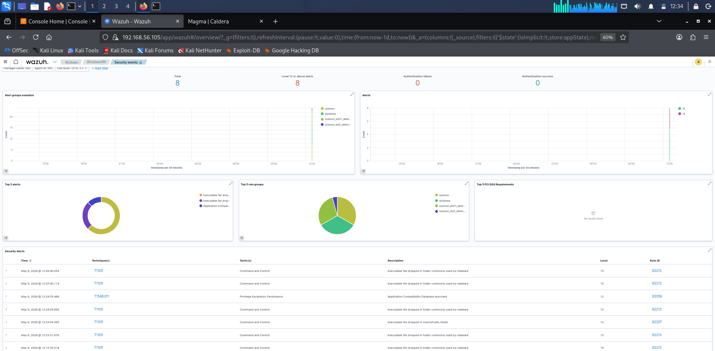

Blue Team Detection
Wazuh successfully detected multiple adversary activities generated through Caldera operations, including command execution, persistence attempts, and suspicious process behavior. Security dashboards and event logs provided visibility into attack stages, enabling Blue Team correlation, monitoring, and investigation of simulated APT29 tactics mapped to MITRE ATT&CK techniques.

Findings
- Caldera effectively simulated adversary behavior mapped to MITRE ATT&CK.
- Wazuh provided centralized visibility into endpoint activity and alerts.
- Persistence and execution techniques generated detectable telemetry.
- The lab demonstrated the importance of detection engineering and log correlation.
- Blue Team monitoring improved understanding of attacker behavior patterns.

Conclusion

The adversary emulation lab successfully demonstrated how offensive security tools such as Caldera and Evilginx2 can simulate realistic attack behavior for defensive validation. Wazuh provided effective monitoring and event analysis capabilities, allowing Blue Teams to identify attack indicators and improve detection strategies.

